**IN MEMORY OF LINDA EVERETT**

by Pierre and Irene Beaudry, 10/26/22

Linda’s exuberant love of art in all of its forms caused her to become one of the most talented artists and thinkers in the LaRouche organization. I am proud to have been a friend of hers and an admirer of her works.

Although Linda’s life was increasingly interrupted by surgeries, she only growled for a moment and then went on to share with people her optimism about humanity and the future of mankind. Here is one example.

When U. S. troops abandoned Afghanistan to its misery, in August of 2021, Linda composed a message that she shared with me and others in July of that year, while she was in the middle of her fight against what she used to call jokingly “my body’s mutiny:” The exchange was as follows:

**THE JOY IN DEVELOPING THAT BIG ROCK, KHYBER PASS (Afghanistan)**

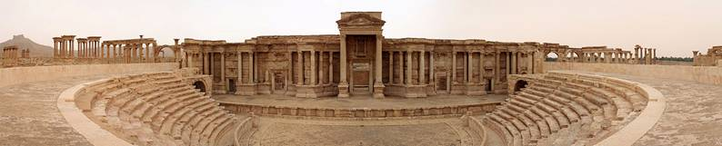

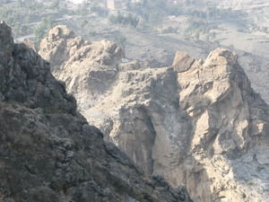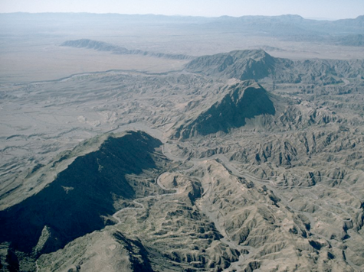

Linda made a beautiful connection between those two distant and yet very similar civilizations of the ancient world, Syria and Afghanistan; however, Syria had a chance to tame its rocky body into classical beauty, Afghanistan did not....

Who else but Linda would have the courage and the sublime irony to be concerned with the immortality of people on the other side of the globe while she had just undergone a torturous 7 weeks of putting her own rocky body together for what tragically became a short period of time. In almost the same breath, Linda wrote:

“My body has committed mutiny and I am awaiting a few surgeries, so I am unable to manage w/o help from aides provided through the county. In the past 6-7 weeks, I've been exposed twice to covid by aides who had it but worked with me anyway (we know how desperate millions are to feed their family or to send funds back to their old country), so I was in necessary isolation which meant cancelling critical tests and an appt. w/ a specialist that took three months to get. I was w/o help much of that time. Obviously, this scourge isn't going away until we move on all Lyn has said and Helga is taking on:  productive jobs, healthcare, vaccines and seeing each individual as a precious person whose genius, creativity the world can't do without.”

Who else but Linda had such a courageous form of optimism?

Thank you, Lynda for your gifted “benefit of the other.”

